CAS PY 106

Lecture Note 19

1. Pictorial approach to Lenz’s Law
2. Example) A wire loop in the plane of the page is in uniform magnetic field directed into the page and over some time interval, field is doubled. What direction is the induced current in the loop while the field is changing?
3. Step 1: Draw a before picture, showing the field passing through the loop before the change takes place



1. Step 2: Draw an after picture, showing the field passing through the loop after the change



1. Step 3: Draw a “To oppose” picture, showing the direction of the field that loop creates to oppose the change



1. Use the right-hand curl rule to determine which way the current moves through the loop to create the opposing field
2. Moving a loop in or out a magnetic field
3. Moving a conducing loop into an area with a B-field will increase the magnitude of flux
4. 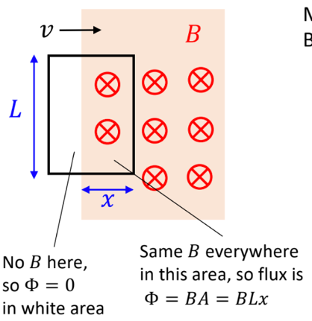

Ɛ = -N \* delta(O) / delta (t)

Ɛ = -N \* delta(BA) / delta (t)

Ɛ = -N \* delta(BLx) / delta (t)

Ɛ = -N \* BL delta(x) / delta (t)

Ɛ = -BLv

1. Motional emf:
2. Metals are special, because some of the electrons can freely move around
3. Some are pushed left, others pushed up, etc
4. Net effect: electrons don’t go in any particular direction
5. Motional emf: moving the metal
6. 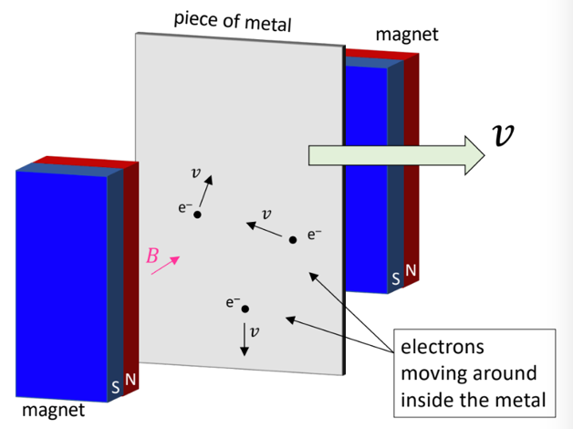
7. Let’s consider one electron after the metal moves in between the magnets
8. 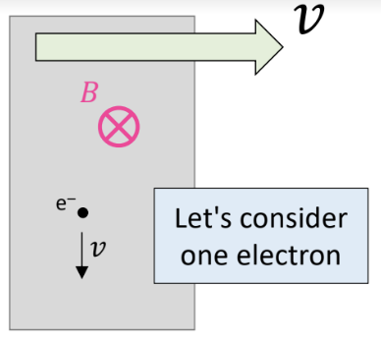
9. On average, the electrons feel a force down by applying the right hand rule
10. 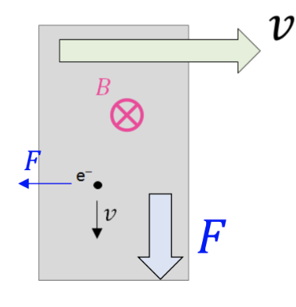
11. The result: bottom of metal becomes negative, leaving the top positive
12. 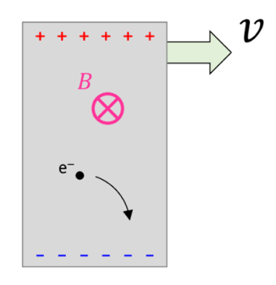
13. This is like a battery (we are generating a voltage (emf))
14. 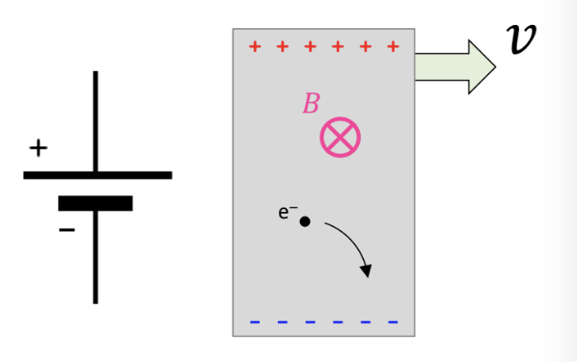
15. Motional emf
16. Electrons keep moving down until their net force becomes zero

Fe=Fm

qE = qvB

1. Estimate electric field with E = delta(V) / d = |Ɛ| / K of parallel plate capacitor, then

|Ɛ|/L = vB

|Ɛ| = vBL

1. Acting like a battery
2. The moving rod can act like a battery if we connect it up in a circuit
3. 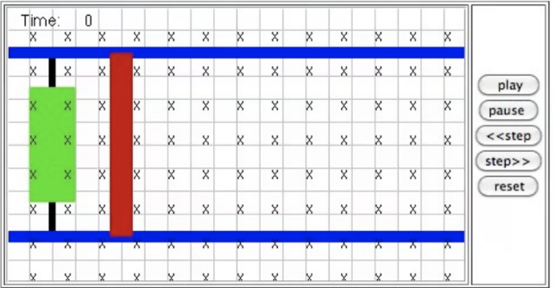
4. The rod is placed on a pair of conducting rails that are separated by a distance L. The rails are connected at the left by a resistor of resistance R – assume the resistance of the rod and rails is negligible compared to R. There is a uniform magnetic field of magnetic field of magnitude B directed into the page
5. Lenz’s Law: What is the direction of the induced current?
6. 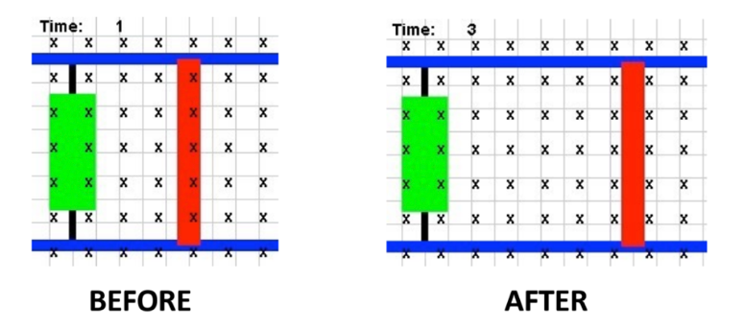
7. The simulation draws the Before and After pictures for us. To oppose the change, the loop needs to create field lines out of the page, requiring a counterclockwise induced current.
8. Acting like a battery
9. The rod is initially at rest, but is then subjected to a constant Force F directed right. Neglect friction between the rod and the rails. What happens?

* The changing flux gives rise to another force opposite in direction to F that causes the bar to reach a terminal (constant) velocity